- Create user with name Techie and provide sudo access
Created User Techie and added to sudo group.
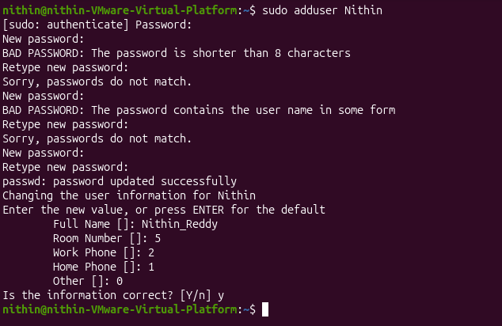
2. Navigate to the home directory
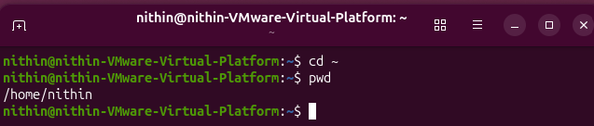

- Create a new directory
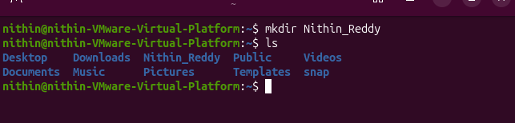

- List contents of a directory

- Change current director
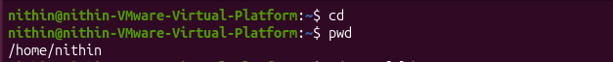
- Create a new empty file

- View contents of a file
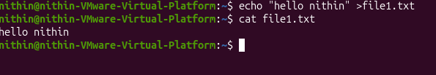
- Copy file to another location
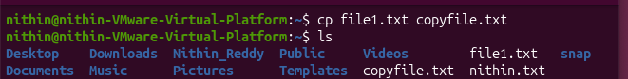
- Move a file to another location
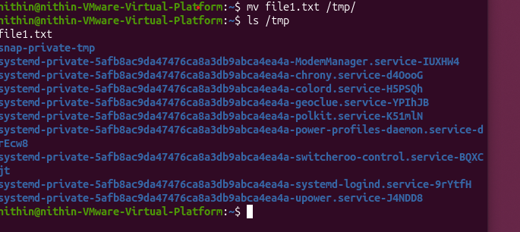
- Rename a file
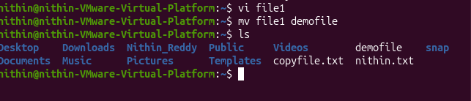
- Delete a file
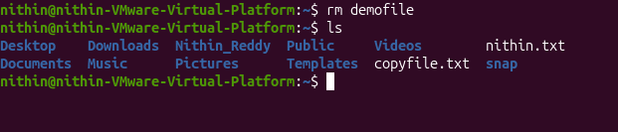
- Grant or revoke permissions
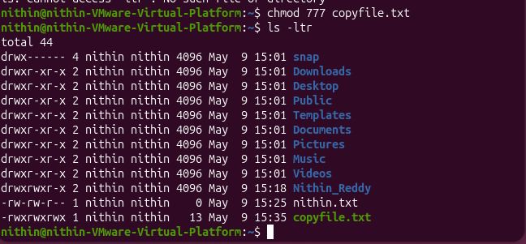
- View current date and time

- Check system uptime
- View running processes
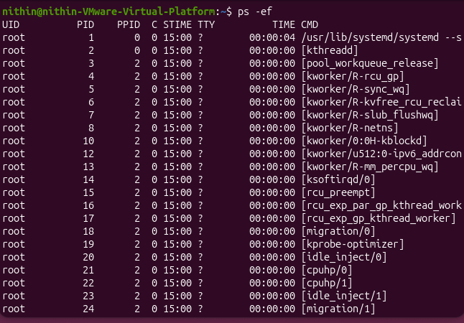
- Kill a running process
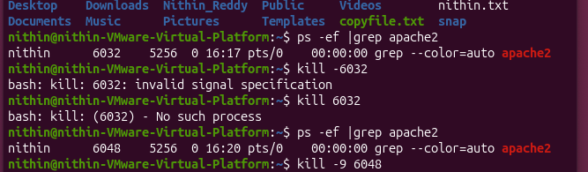
- Install a package using apt
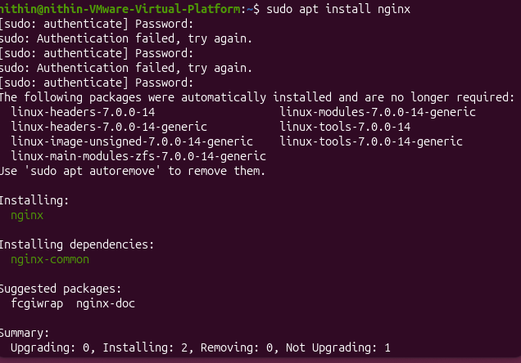
- Update the system packages
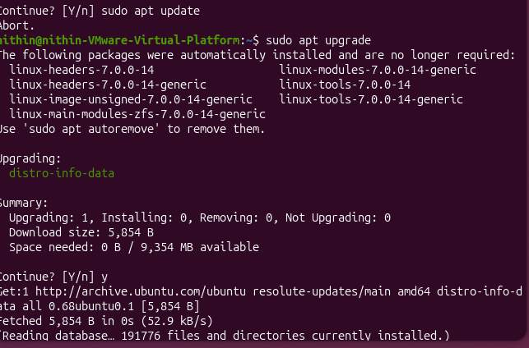
- Create a symbolic link
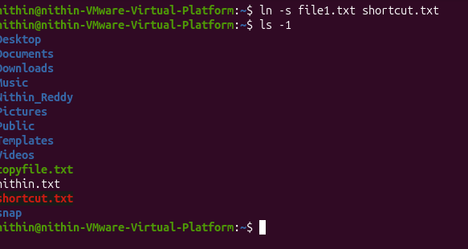
- Search files using find
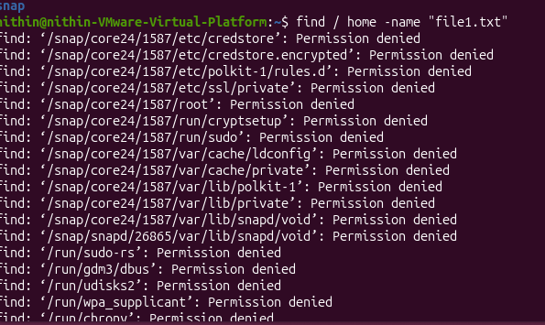
- Compress and decompress using tar
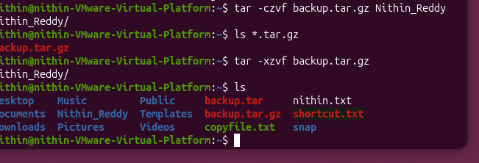
- Monitor system resources
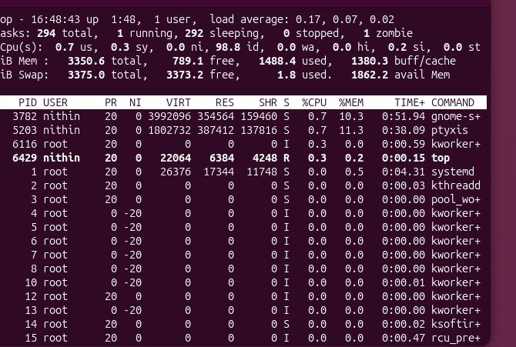
- Create and manage user groups
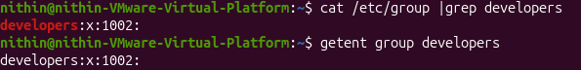
- Set up SSH password less authentication
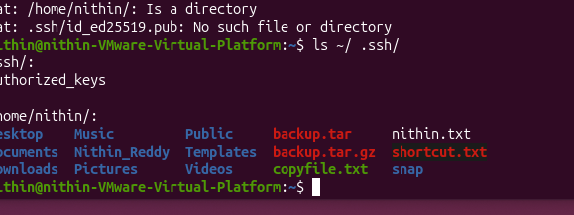
- Monitor logs using tail or grep
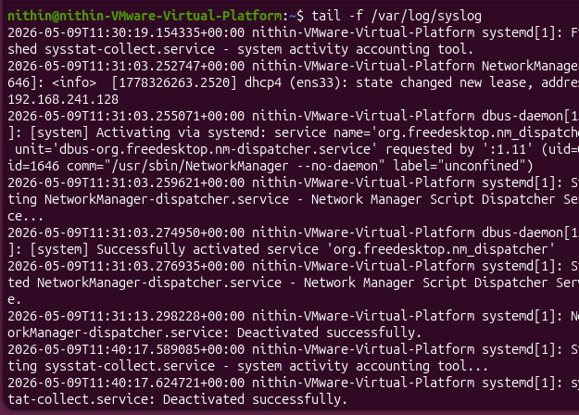
- Set up Apache web server
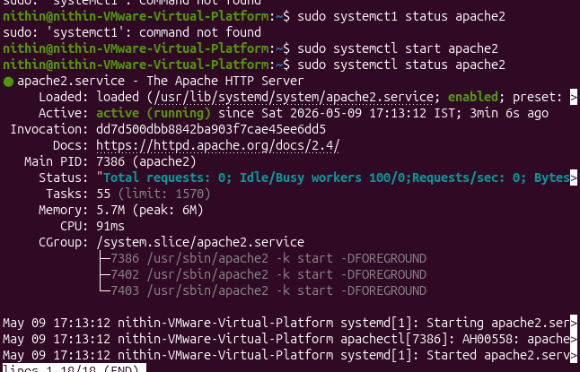
- Configure and secure MySQL
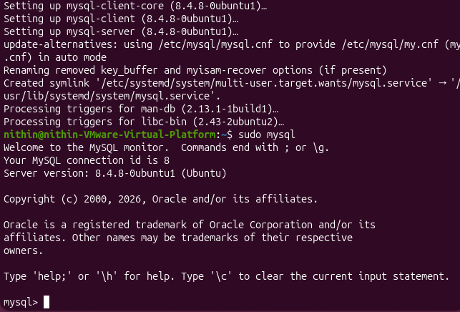
- Set up Apache Tomcat
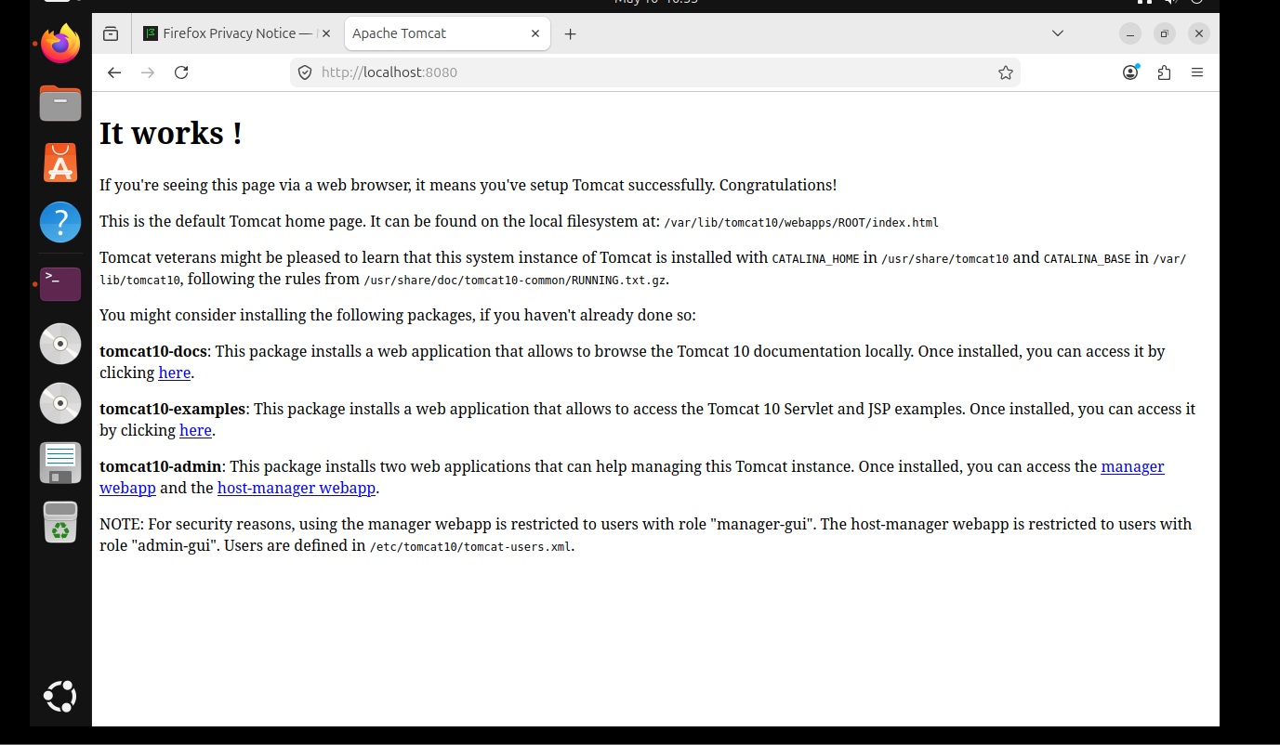
- Create Tomcat service file
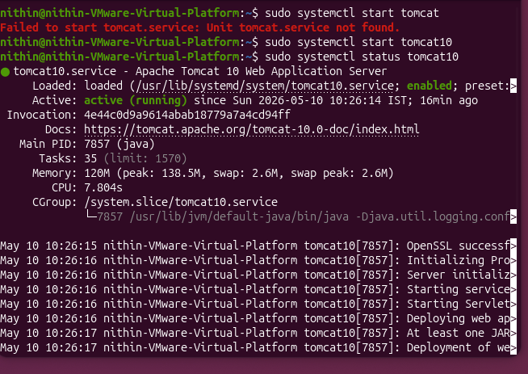
- Print specific columns
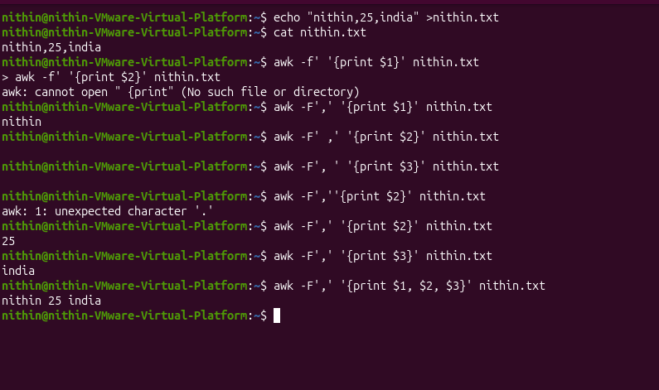
- Filter lines by pattern
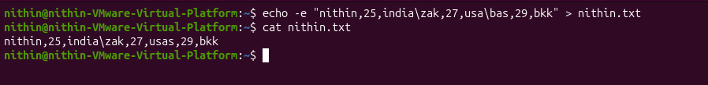
- Calculate average/sum
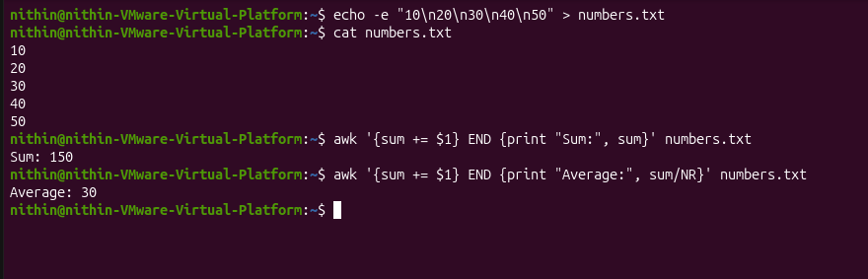
- String manipulation
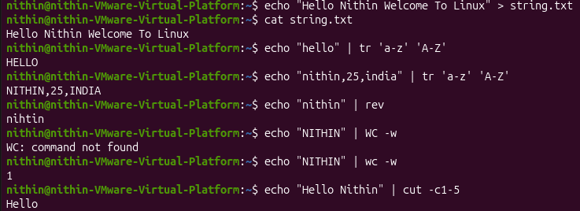
- Count occurrences of pattern
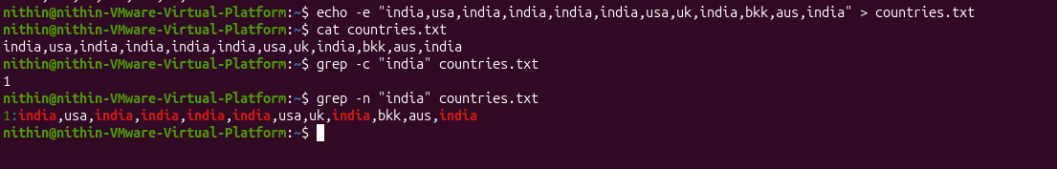
- Sort lines based on column
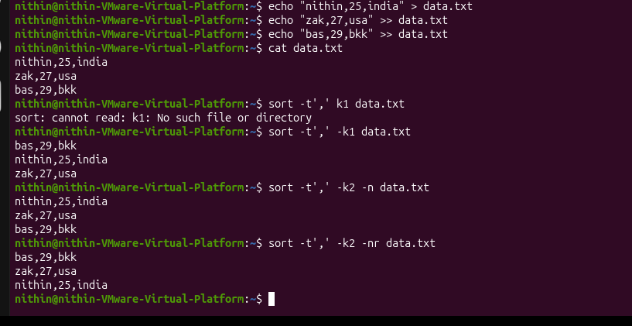
- Merge files using join
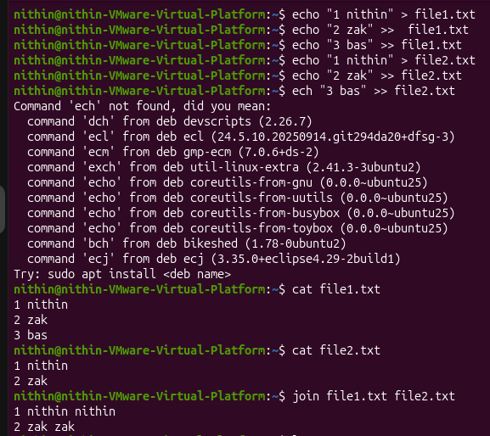
- Substitute text using sed
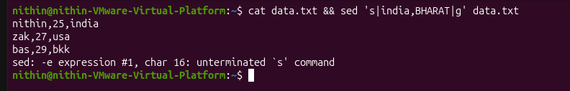
- Delete specific lines
- Append or insert text

- Print only specific lines
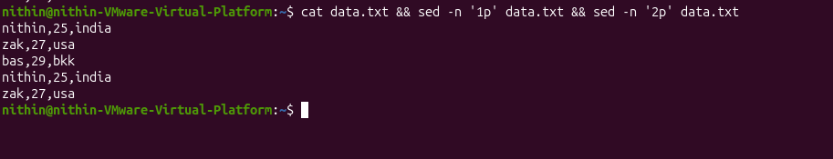
- Copy file from Linux to Windows
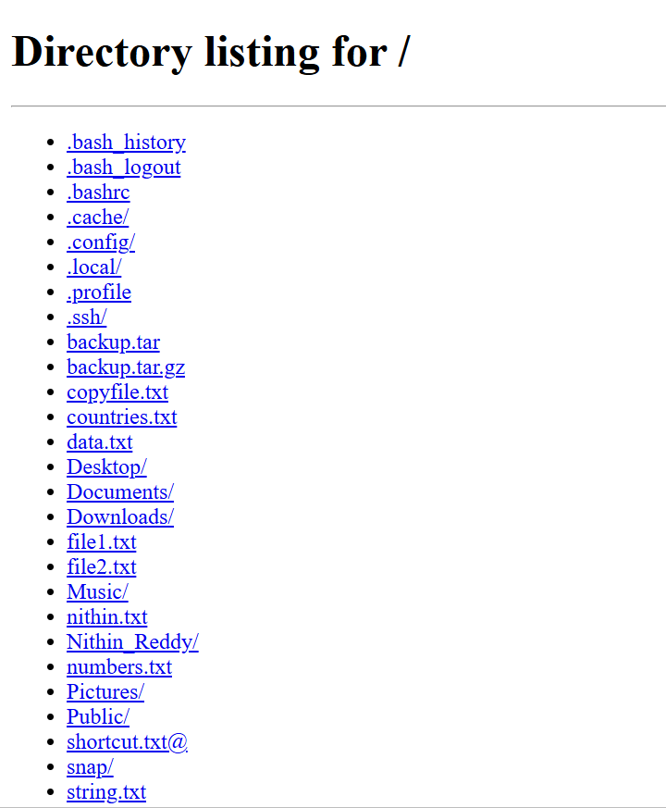

- AWK and sed Use Cases
